

**IPRC TUMBA**

Integrated Polytechnic Regional College

P.O. Box 6638 Rulindo

Tel: +250 786000011

Email:info@iprctumba.rp.ac.rw

www.iprctumba.rp.ac.rw

**DEPARTMENT OF INFORMATION AND COMMUNICATION TECHNOLOGY**

**CEMETERY PAYMENT INFORMATION SYSTEM**

Case Study: CEMETERY

A project report submitted for partial fulfillment of the requirements for the award of

Advanced Diploma in Information and Communication technology

**Submitted by**

NSHIMIYIMANA Dieudonne (**19RP02838**)

And

UWIDUHAYE Marie Josée 1(**19RP00790**)

**Supervised by**

MUVANDIMWE Anastase

**Academic year**

2021-2022

Northern Province, Rwanda

December 1,2022

DECLARATION

We hereby declare that we carried out the work reported in this report in the Department of Information and communication Technology IPRC Tumba, under the supervision of **Mr.** **MUVANDIMWE Anastase**. we solemnly declare that to the best of our knowledge, no part of this report has been submitted here or elsewhere in a previous application for award of an academic qualification. All sources of knowledge used have been duly acknowledged.

|  |  |
| --- | --- |
| Signature …………………  Date……. /…. /2022 | Signature……………….  Date…………/………. /2022 |
| **NAMES: NSHIMIYIMANA Dieudonne**  **REGISTRATION NO: 19RP02838** | **NAMES: UWIDUHAYE Marie Jose**  **REGISTRATION NO: 19RP00790** |

# APPROVAL

This is to certify that the project titled **“CEMETRY PAYMENT INFORMATIONSYSTEM”** carried out by **NSHIMIYIMANA Dieudonne** and **UWIDUHAYE Marie Jose** has been read, checked and approved for meeting part of the requirements and regulations governing the award of the Advanced Diploma of Information and Communication Technology of IPRC Tumba, Rwanda.

|  |  |
| --- | --- |
| MUVANDIMWE Anastase | Signature………… |
| Project Supervisor  SAKINDI Jean Baptiste  Project examiner 1  MUGABE Wilson  Project examiner 2 | Date……/…. /2022  Signature…………  Date …. /……/2022  Signature …………  Date …. /……/2022 |
| Mr. Etienne HAVUMIRAGIRA | Signature………… |
| Head of Department | Date……/……/2022 |

# DEDICATION

I would like to dedicate this final project:

* To the almighty God for his protection,
* To my parents,
* To my brothers and sisters,
* To my colleagues and classmates,
* And to all my friends

# ACKNOWLEDGMENTS

We would like to present our thanks to the staff of IPRC TUMBA. Special thanks are addressed to our supervisor for his tireless effort, guidance and support. Our sincere gratitude goes to ICT department members.

We are also very grateful to our parents, relatives and friends for their valuable support throughout the years of my education. Thanks to those who have so faithfully supported our life and this part in it.

# ABSTRACT

In our country, there are the problems of walking long journey and time wasting for bereaved during making payment of graves to the cemetery owner because there is no way to contact with them and pay through technology. Other problem is that it is difficult to know number of graves sold per day because they write all records on paper.

Observations, interviews were used as major data collection techniques. It is through the system analysis and software engineering concepts, the conception and development of Cemetery payment information system was done as detailed and described in the third chapter.

Table of Contents

DECLARATION i

APPROVAL ii

DEDICATION iii

ACKNOWLEDGMENTS iv

ABSTRACT v

LIST OF TABLES ix

LIST OF FIGURES x

LIST OF ABBREVIATION xi

CHAPTER 1: GENERAL INTRODUCTION 1

1.0 Introduction 1

1.1 Background of the study 1

1.2 Statement of problems 1

1.3 Objectives of the study 2

1.3.1 General Objective 2

1.3.2 Specific objectives 2

1.5 Significance of the study 2

1.5.1 To the researchers 2

1.5.2 To cemetery leaders 3

1.5.3 To government 3

1.6 Research questions 3

1.7 Organization of the study 3

CHAPTER 2: THE LITERATURE REVIEW 5

2.0 Introduction 5

2.1 Definition of key terms 5

2.1.1 Cemetery 5

2.1.2 Grave 5

2.1.3 System 5

2.1.4 Information 5

2.1.5 Information system 5

2.1.6 API (Application Programming Interface) 6

2.1.7 Android Studio 6

2.2 Related Literature 6

2.2.1 Cemetery Management System (CMS) 6

2.3 Summary 7

CHAPTER 3: RESEARCH METHODOLOGY 8

3.0 Introduction 8

3.1 Population and selection of the sample 8

3.1.1. Population 8

3.1.2. Sampling 8

3.2 Tools for data collection/instrumentation 8

3.3. Data collection methods 8

3.3.1. Interview 9

3.3.2 Observation 9

3.4 Data Analysis 9

3.5 Validity and reliability 10

3.5.1 Validity 10

3.5.2 Reliability 10

3.6 Ethical consideration 10

CHAPTER 4: SYSTEM ANALYSIS AND DESIGN 11

4.1. Introduction 11

4.2. Data analysis and presentation 11

4.3. Interpretation of findings/ results 11

4.4. Description of Existing System 11

4.5. Description of the New System 11

4.5.1. Modules 12

4.5.2. System configuration and technology (Platform) 12

4.6. Illustration of the new system 12

4.6.1. Data Flow Diagram (DFD) 12

4.6.2. Use case diagram 13

4.6.3. Data Dictionary 15

4.6.4. Entity Relationship Diagram 20

4.7. Architecture design of the new system 21

CHAPTER 5: IMPLEMENTATION, CODING AND TESTING 22

5.1. Implementation and Coding 22

5.1.1. Introduction 22

5.1.2. Description of implementation tools and technology 22

5.1.3. Screen shots and source code 22

5.2. Testing 25

5.2.1 Introduction 25

5.2.2 Testing technique 25

CHAPTER 6: CONCLUSION AND RECOMMENDATIONS 27

6.0 Conclusion 27

6.1 Recommendations 27

References 28

# **LIST OF TABLES**

Table 1:Admin table 15

Table 2: Cemetery table 16

Table 3:Cemetery-user table 16

Table 4:List table 17

Table 5:Payment table 18

Table 6:People table 19

Table 7: Acceptance testing table 26

# LIST OF FIGURES

Figure 1:Data Flow Diagram (DFD) 13

Figure 2:Use case diagram of admin and cemetery-user 14

Figure 3:Entity Relationship Diagram 20

Figure 4:architecture of new system 21

Figure 5:Admin login 22

Figure 6:Administrator dashboard 23

Figure 7: admin is adding cemetery user 23

Figure 8:registered customers and their status(payment report) 24

Figure 9:cemetery user login 24

Figure 10:Cemetery user dashboard 25

# **LIST OF ABBREVIATION**

API: Application Programming Interface

CMS: Cemetery Management System

IT: Information Technology

DFD: Data Flow Diagram

ERD: Entity Relation Diagram

JDK: Java Development Kit

RDBMS: Relational Database Management System

My SQL: My Structured Query Language

IPRC Tumba: Integrated Polytechnic Regional Centre Tumba

# CHAPTER 1: GENERAL INTRODUCTION

## 1.0 Introduction

Information and Communications Technology (ICT) has an important role in the world since we are now in the information age era. With ICT, the company can make the business easier to happen with the client, supplier, and distributor. It is also very important in our daily lives. The lack of appropriate information at the right time will result in low productivity, low-quality research works, and waste of time to pursue information and even to do research which others had done or in other countries. Nowadays ICT cannot be separated from our daily needs

CEMETERY PAYMENT INFORMATION SYSTEM is all about helping the bereaved to eradicate the problems of not having a place to bury their died person by first of all highlighting issues and their causes then provide solutions to this problem by educating those problem of bereaved how much is difficult to get where to bury dead person.

Our study has focused on problems caused by lack of place where to bury that is why we came up with the idea of how to pay it online. CEMETERY PAYMENT INFORMATION SYSTEM can be in form of web-based as well as mobile application in order to let the service be available to everyone who want grave for burying his/her died person.

## 1.1 Background of the study

Information technology is widely used and is rapidly becoming a common asset of modern in all private cemetery

The cemetery has a long way to attain success in this area because everyday peoples die and be buried. Software development and the use of automated systems, network system development the need of sharing resources within the country and also global, this became other things that hold largely of measure for development in the Rwandan cemetery.

## 1.2 Statement of problems

In fact, there is a problem of wasting time and making a long journey by the bereaved to ask if there are graves to bury their loved ones who passed away because there is no digital way to pay graves without going to the cemetery owner’s office.

## 1.3 Objectives of the study

### 1.3.1 General Objective

The main objective of this research is to come up with reliable system that will handle the clear issue, through the presence of online services.

### 1.3.2 Specific objectives

* Avoiding time wasting
* Request graves via Smart phone
* Pay grave by using MTN Mobile Money

**1.4** **Scope of study**

**1.4.1 Time scope**

This Cemetery Payment Information System conducted from July 2022 to November 2022

**1.4.2 Geographical location of the study**

The study would take place in cemeteries which is located in all districts of Rwanda

**1.6.3 Content scope**

The study focuses on Cemetery Payment Information System. This system will focus on booking and paying grave. The cemetery leader will also use this by checking the activity done to the system.

## 1.5 Significance of the study

### 1.5.1 To the researchers

The present work gives the researchers the opportunity to improve practical knowledge in the field of web and mobile applications development especially in databases management system, system analysis, application design and to be able to compete on labor market.

### 1.5.2 **To cemetery leaders**

This project will help them to have full of information about sold graves, collect the money paid in easy way. This application will help leaders to determine if they have enough capacity to satisfy graves buyers.

### 1.5.3 To government

The government may use CEMETERY PAYEMENT INFORMATION SYSTEM data to see the walk long distance of people problem status and use those data while setting new policies andit will help the government determine the actual tax that should be paid based on the number of graves sold.

## 1.6 Research questions

From the beginning of this research there is critical questions our research based on, so that we need that the process will come up with real solution, those are:

* Does the leader of cemetery know the effect of bereaved walking long distance for asking if there are graves?
* What is the main cause of long distance among lack of online system for accessing their service?
* In which way ICT can become a part of solution against walking long distance and wasting time problem?

## 1.7 Organization of the study

This project report is divided into six chapters:   
The first chapter deals with the general introduction of this project; it contains the statement of  
the problem, project objectives, hypothesis, the scope of the project, the interests of the project  
and the organization of the work.  
The second chapter deals with the literature review.  
The third chapter deals with the research methodology.  
The fourth chapter concerns the System analysis and design of the project.

Chapter five deals with implementation, coding and testing  
The sixth chapter deals with the conclusion and recommendations.

# CHAPTER 2: THE LITERATURE REVIEW

## 2.0 Introduction

This process usually includes a study of the current system and its problems and envisioning ways to design a new system. Analysis of current system helps in giving a detailed view and understanding of how the present system works. The analysis will give an indication of the problems faced in the current system and give clear direction of how to solve the problems by either improving or replacing the current system.

## 2.1 Definition of key terms

### 2.1.1 Cemetery

A cemetery is a designated place where the remains of people who have died are laid to rest in specific, identifiable burial sites. (Pearson, 1999)

### 2.1.2 Grave

Grave refer to the place in the [ground](https://www.ldoceonline.com/dictionary/ground) where a [dead](https://www.ldoceonline.com/dictionary/dead) body is [buried](https://www.ldoceonline.com/dictionary/bury). (Sprague, 2005)

### 2.1.3 System

A system is a collection of elements related in a way that allows a common objective to be accomplished. In computer systems, these elements include hardware, software, people, facilities, and processes. (Thayer, 2002)

### 2.1.4 Information

Information is organized or classified data, which has some meaningful values for the receiver. Information is the processed data on which decisions and actions are based. For the decision to be meaningful, the processed data must qualify for the following characteristics. (Migueles, 2017)

### 2.1.5 Information system

An information system (IS) is an arrangement of people, data, processes, communications, and information technology that interact to support and improve day-to-day operations in a business as well as support the problem solving and decision-making needs of management and users. (Davenport, 1990)

### 2.1.6 API (Application Programming Interface)

An API is a set of programming code that enables data transmission between one software product and another. (Foster, 2001)

### 2.1.7 Android Studio

Android Studio is the official integrated development environment for Google's Android operating system, built on Jet Brains' IntelliJ IDEA software and designed specifically for Android development. (Mathur, 2021)

## 2.2 Related Literature

### 2.2.1 Cemetery Management System (CMS)

It is management system that securely stores cemetery maps and records in one place, making management easier for the dedicated people who keep their cemeteries information. (Last, 2017)

CMS help by organizing the following tasks:

* Map grounds, keep track of plot availability and provide support to families in need***.***
* Increase sales by keeping track of plots that are available for sale.
* Establish best practices by managing records about burials, vaults and property sales.
* Determine records most in need of maintenance.
* Manage financial information, customer information and payments to increase cash flow.

**2.2.2 Chronicle**

Chronicle is an easy-to-use cemetery management software that gives accessible solution to accurately manage your cemetery's data, with stunning visualizations of its space, plots, and records. We help all types of cemetery in digitizing records and mapping, streamline their daily task by ensuring record integrity, easily locatable burial, and other features all in one easy-to-use platform. Chronicle has been created to help cemetery manager to build, track, manage, organize database records, and share their community's history with an interactive and accurate mapping. This is how Chronicle provides solutions and values to cemeteries: Ease and Save Time. Our digital cemetery mapping process and technology (aerial and grave coordinate survey) guarantees 99% accuracy in cemetery record and mapping. Safe and Secure. We use prioritize security of data and use industry leading IT Security Standard Scalable Solutions Across Multiple Cemeteries. One easy-to-use online software to manages multiple cemeteries, thousands of plots, hundreds of interments. We Take Care of Your Records. We digitize your records into one consolidate database with each burial linked to a physical grave location on Chronicle online cemetery map. Integrations with existing IT systems. Connect Chronicle to your day-to-day software (TechOne, Civica, QuickBooks, etc.). Value for Money. We strive to provide better service and quality of output. (Paton, 2014).

## 2.3 Summary

We summarized that CMS and Chronicle are the related project and are running well but it is not used in our country. The above related projects are for mapping graves and storing data electronically and its weakness is that there is no feature of payment via mobile.

The reasons why we decide to develop this system are to solve problem of walking long journey and wasting time.

# CHAPTER 3: RESEARCH METHODOLOGY

## 3.0 Introduction

This chapter explains various stages and phases that were followed in completing the study. It provides a deep definition and description of research design, different participants, sampling, data collection and data presentation validity and reliability, finally ethical consideration and summary.

## 3.1 Population and selection of the sample

It would normally be impractical to study a whole population, for example when doing a questionnaire survey. Sampling is a method that allows researchers to infer information about a population based on results from a subset of the population, without having to investigate every individual. Reducing the number of individuals in a study reduces the cost and workload and may make it easier to obtain high quality information, but this has to be balanced against having a large enough sample size with enough power to detect a true association. (Calculation of sample size is addressed in section 1B (statistics) of the Part A syllabus.)

### 3.1.1. Population

We focused on people who live around Rusororo cemetery especially those who are suffering from mental illness related issues.

### 3.1.2. Sampling

Samples have been taken among 2 to 5 Rusororo cemetery bereaved.3.1.3. Sampling techniques

## 3.2 Tools for data collection/instrumentation

Data collection tools refer to the devices/instruments used to collect data, such as a paper questionnaire or computer-assisted interviewing system

* Smartphone
* Papers
* Pen

## 3.3. Data collection methods

The Data Collection Techniques is defined as the process of understanding how the current system works, its working principles, the characteristics and the limitations in order to come up with the new system that provides effective service, the researcher used the following techniques to data collection, Interview and Observation techniques as follows.

### 3.3.1. Interview

In this research, we used interview schedule as the data collection method, it is a face to face conversation between the interviewer and the respondent conducted for obtaining information, this method assumes that the respondent interviewer has the required information.

Interview can be conducted depending on the researcher either in person or over the telephone, but face-to-face interview excludes the use of telephone.

This is one of two interviews used for gathering information about projects marketing system. (Ryan, 2007)

We interviewed the owner of Rusororo cemetery by asking him the system used to manage cemetery daily activity.

### 3.3.2 Observation

Observation is another data collection method, this method helps me understand the functioning of an existing system, it is a type of research strategy consisting of study or discovering the current situation in order to take action. (Richards, 1994)

After in interviewing cemetery owner, we observed the activity done at Rusororo cemetery where there is no digital way of payment.

## 3.4 Data Analysis

We conducted the analysis for the purpose of studying a system or its parts in order to identify its objectives.

Analysis helped us to specify what the system should do, and after all we have seen that it is important bereaved will miss way of paying grave. in addition, all data are said to have integrity this assures that the information stored is valid, accurate and consistency.

## 3.5 Validity and reliability

### 3.5.1 Validity

**Validity** is the extent to which the scores from a measure represent the variable they are intended to.

### 3.5.2 Reliability

**Reliability** refers to the consistency of a measure. Psychologists consider three types of consistency: over time (test-retest reliability), across items (internal consistency), and across different researchers (inter-rater reliability)

## 3.6 Ethical consideration

Ethical consideration is a collection of principles and values that should be followed while doing human affairs. The ethical considerations make sure those no-one acts in such a way that is harmful to society or an individual.

# CHAPTER 4: SYSTEM ANALYSIS AND DESIGN

## 4.1. Introduction

This chapter discusses the process of system analysis, design, development, implementation and testing. The system design is done following the findings from the data gathered. All the user requirements obtained from feedback in the data collection phase are used to design a system that fulfills the users’ needs. After the system implementation, testing will be done on the intended users in order to confirm that the system is suitable for them, and to determine if the objectives have been achieved.

## 4.2. Data analysis and presentation

Data Presentation forms an integral part of all academic studies, commercial, industrial and marketing activities as well as professional practices. Presentation requires skills and understanding of data. It is necessary to make use of collected data which is considered to be raw data. It must be processed to be used for any application. Data analysis helps in the interpretation of data and helps take a decision or answer the research question. This can be done by using various Data processing tools and Software’s.

## 4.3. Interpretation of findings/ results

It is with a help of this system that no bereaved will make journey to the cemetery to make payment, in addition all data are said to have integrity this assures that the information stored is valid, accurate and consistency.

## 4.4. Description of Existing System

The current system used a tradition method which is not with the age of technology where the a bereaved took time to go to the cemetery to pay for the burial and the time is lost once there is no graves.

## 4.5. Description of the New System

We intend to develop the application that will help the bereaved, where they will no longer travel to the cemetery to pay grave they will pay it with the help of a modern telephone.

### 4.5.1. Modules

This system is divided into three modules which are admin, cemetery user, and customer and they are classified according to users and their responsibilities

### 4.5.2. System configuration and technology (Platform)

* Apache Web server that actsas the Web server. (Glass, 2004)
* **MySQL** which is a very capable relational client/server database system. (Kofler, 2004)
* PhpMyAdmin which is an open-source tool written in PHP intended to handle the administration of MySQL with the use of a browser. (McLaughlin, 2012)
* Android which is a mobile operating system developed by Google used by several smartphones and tablets. Examples include the Sony Xperia, the Samsung Galaxy, and the Google Nexus One (Firtman, 2013).

## 4.6. Illustration of the new system

The system will be in the form of web application for its users with the database to store all information of the cemetery related to the bereaved and services activities like making application, payments and provide graphical users interface for a purpose of being friendly with its stakeholders

### 4.6.1. Data Flow Diagram (DFD)

Data flow diagram (DFD) maps out the flow of information for any process or system. It’s used defined symbols like rectangle, circles and arrows plus short text labels, to show data input, outputs, and storage points and the routes between each destination. (Prachkina, 2019).



Figure 1:Data Flow Diagram (DFD)

### 4.6.2. Use case diagram

A use case is a methodology used in system analysis to identify, clarify, and organize system requirements. The use case is made up of a set of possible sequences of interactions between systems and users in a particular environment and related to a particular goal. It consists of a group of elements that can be used together in a way that will have an effect larger than the sum of the separate elements combined. The use case should contain all system activities that have significance to the users. (Eriksson, 2003)

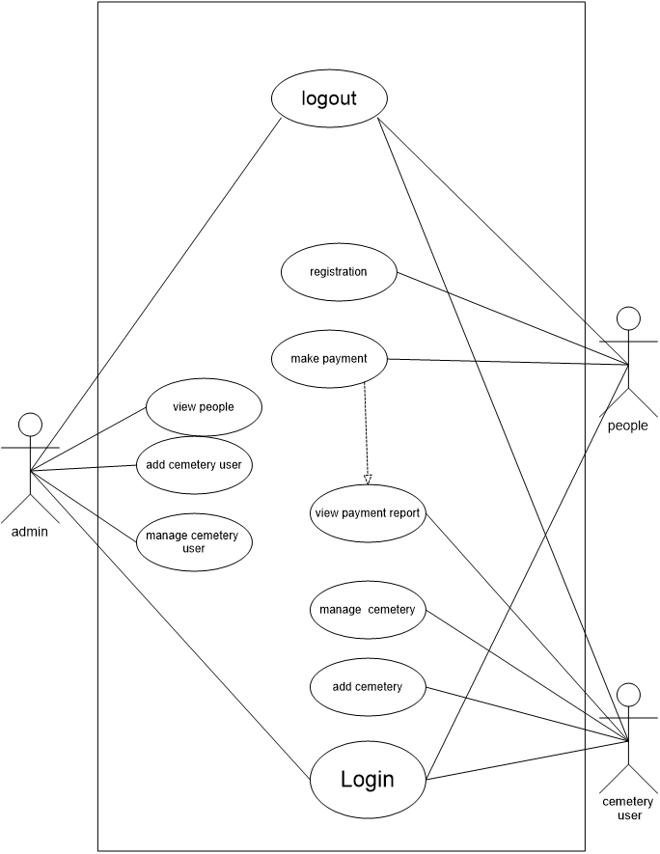

Figure 2:Use case diagram of admin and cemetery-user

### 4.6.3. Data Dictionary

Administrator table

|  |  |  |  |
| --- | --- | --- | --- |
| Field name | Data type(size) | Description | Constraint |
| Id | Int(11) | Identification | Primary key |
| Username | varchar(50) | name that is used by user to login | Not Null |
| Password | varchar(60) | Password of owner cemetry | Not Null |
| Firstname | varchar(50) | Names of owner cemetry | Not Null |
| Lastname | varchar(50) | Names of owner cemetry | Not Null |
| Photo | varchar(150) | Photo of owner cemetry | Not Null |
| created_on | Date |  | Not Null |

Table 1:Admin table

Cemetery Table

|  |  |  |  |
| --- | --- | --- | --- |
| Field name | Data type(size) | Description | Constraint |
| Cemetery_id | Int(11) | Id of cenmetry | Primary key |
| Cemerty_name | Varcar(45) | Name of cemetry | Not Null |
| Category | varchar(89) | Cemetery dicided two part:poor cemetery and rich cemetry | Not Null |
| Price | varchar(67) | Amount of cemetry | Not Null |
| District | varchar(67) | District of cemetery do you need | Not Null |
| Sector | varchar(65) | Sector of cemetery do you need | Not Null |
| Cell | varchar(78) | cell of cemetery do you need | Not Null |
| Village | varchar(67) | Village of cemetery do you need | Not Null |
| Status | int(11) | Details of cemetery | Not Null |
| created_on | datetime |  | Not Null |

Table 2: Cemetery table

Cemetery user table

|  |  |  |  |
| --- | --- | --- | --- |
| Field name | Data type(size) | Description | Constraint |
| Cem_id | int(11) | Cemetery id | Primary key |
| Firstname | varchar(45) | Name of cemetery | Not Null |
| Lastname | varchar(67) |  | Not Null |
| Username | varchar(78) | Name used when login | Not Null |
| Email | varchar(65) | Email of cemetery user | Not Null |
| Password | varchar(78) |  | Not Null |
| Photo | varchar(78) |  | Not Null |
| Status | varchar(56) | It indicates if he/she is online | Not Null |
| Id | int(11) | identification | Not Null |
| created_on | Date | Date of created | Not Null |

Table 3:Cemetery-user table

List Table

|  |  |  |  |
| --- | --- | --- | --- |
| Field name | Data type(size) | Description | Constraint |
| Prov_ID | varchar(50) | Province identification | *NULL* |
| Province | varchar(50) | Province name | *NULL* |
| Dist_ID | varchar(50) | District identification | *NULL* |
| District | varchar(50) | District name | *NULL* |
| Sect_ID | varchar(50) | Sector identification | *NULL* |
| Sector | varchar(50) | Sector name | *NULL* |
| Cell_ID | varchar(50) | Cell identification | *NULL* |
| Cell | varchar(50) | Cell name | *NULL* |
| Vill_ID | varchar(50) | Village identification | *NULL* |
| Village | varchar(50) | Village name | *NULL* |
| Status | varchar(50) |  | *NULL* |
| FID | varchar(50) |  | *NULL* |

Table 4:List table

Payment Table

|  |  |  |  |
| --- | --- | --- | --- |
| Field name | Data type(size) | Description | Constraint |
| Pay_id | Int(11) | Payment identification | Not Null |
| Amount | Varchar(78) | Amount of money to be paid | Not Null |
| Phonenumber | Varchar(78) | People phone number | Not Null |
| Cemetery_id | Int(11) | Cemetery identification | Not Null |
| People_id | Int(11) | People identification | Not Null |
| Status | Int(11) | Payment status | Not Null |

Table 5:Payment table

People Table

|  |  |  |  |
| --- | --- | --- | --- |
| Field name | Data type(size) | Description | Constraint |
| people_id | int(11) | People identification | Primary key |
| Reference | int(45) |  | Not Null |
| Fname | varchar(67) | First name | Not Null |
| Lname | varchar(78) | Last name | Not Null |
| phoneNumber | varchar(65) | People phone number | Not Null |
| Username | varchar(78) | User name used for login | Not Null |
| Password | varchar(67) | Password used for login | Not Null |
| Status | int(11) | People status | Not Null |
| Date | Timestamp | Account created date | Not Null |

Table 6:People table

### 4.6.4. Entity Relationship Diagram



Figure 3:Entity Relationship Diagram

## 4.7. Architecture design of the new system

The architecture of the system describes its major components, their relationships(structure) and how there are interact with the system. The architecture is the blueprint of the system. It provides an abstraction to manage the system complexity and establish communication and coordination among components. (Shaw, 1995)

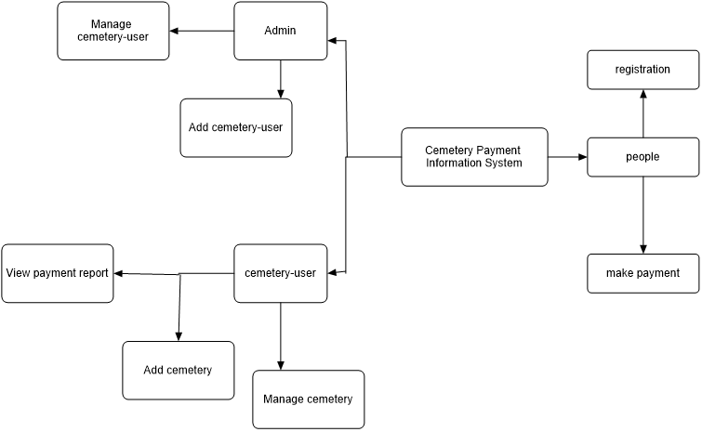

Figure 4:architecture of new system

# CHAPTER 5: IMPLEMENTATION, CODING AND TESTING

## 5.1. Implementation and Coding

### 5.1.1. Introduction

During implementation, the project team creates the actual product. Product implementation can be an exciting phase for the customer, because their idea for the project becomes something tangible. Project developers begin building and coding the software.

### 5.1.2. Description of implementation tools and technology

* Apache Web server
* MySQL
* PhpMyAdmin
* Android
* Java development kit (JDK)

### 5.1.3. Screen shots and source code

This is image for admin login where he/she use his/her credentials to login. Admin has full control for our system he/she has the responsibilities of adding cemetery user, other admin, managing them and viewing people

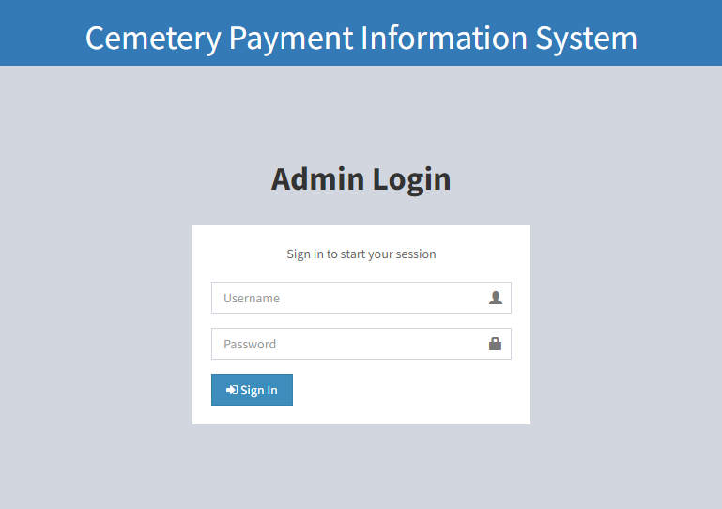

Figure 5:Admin login

The image is an administrator dashboard where all work of an administrator done by here.here provides administration such as manage cemetry user,manage administrator and view people list.

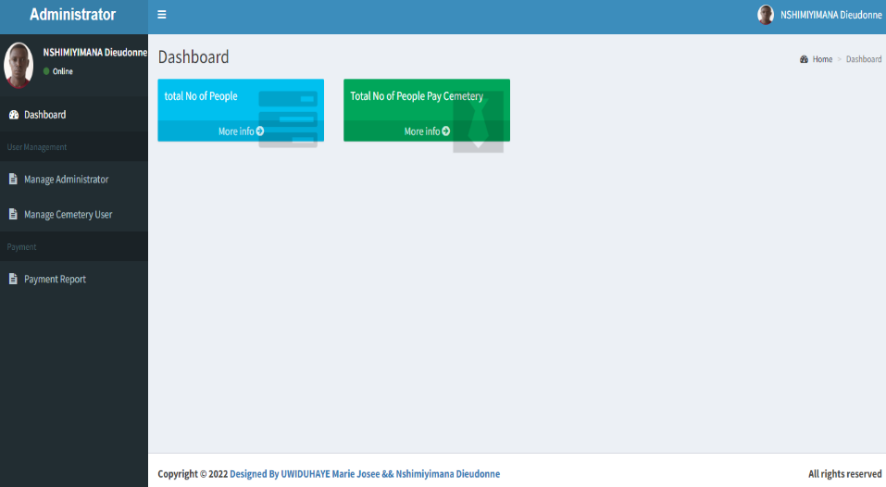

Figure 6:Administrator dashboard

This image shows that admin is adding cemetery user where he/she creates his last name, first name, username, email, and password.

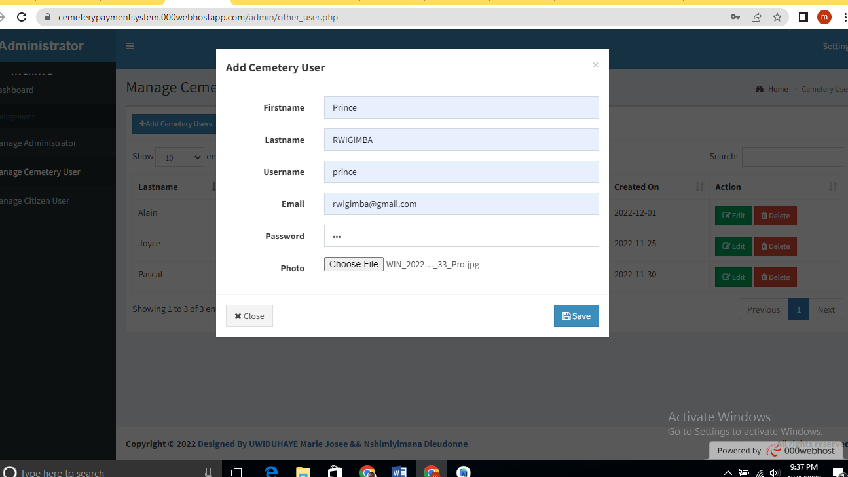

Figure 7: admin is adding cemetery user

This image shows the registered customer and their status of their payment if it is pending, failed or successful.

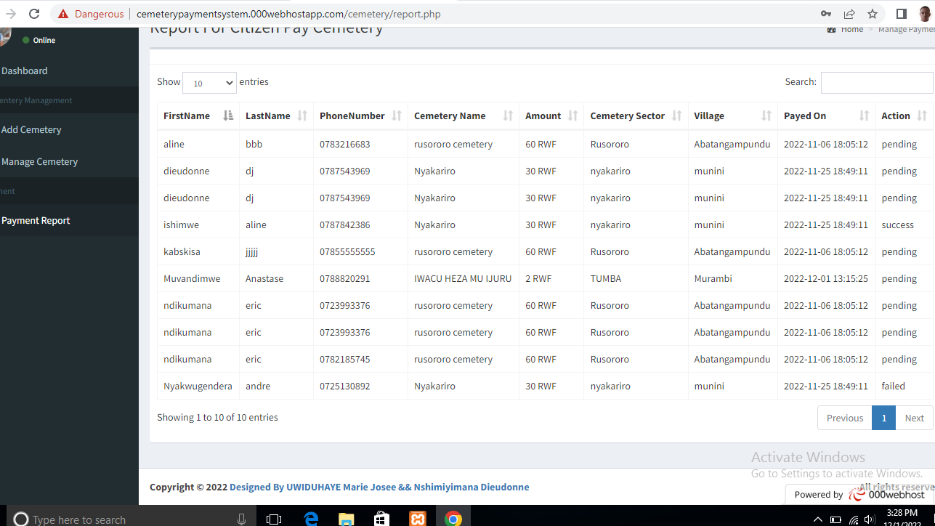

Figure 8:registered customers and their status(payment report)

The image is login page which is used by cemetery user. He/she must go to his/her dashboard according to username and password, typed in this page. The cemetery user has privileges of managing end user’s activity (people)

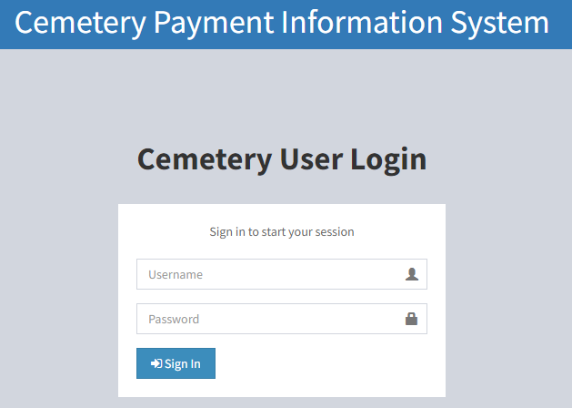

Figure 9:cemetery user login

This image displays the dashboard of cemetery user after logging in, he/she can add cemetery/manage it and viewing payment status if it is pending, failed or successfully paid.

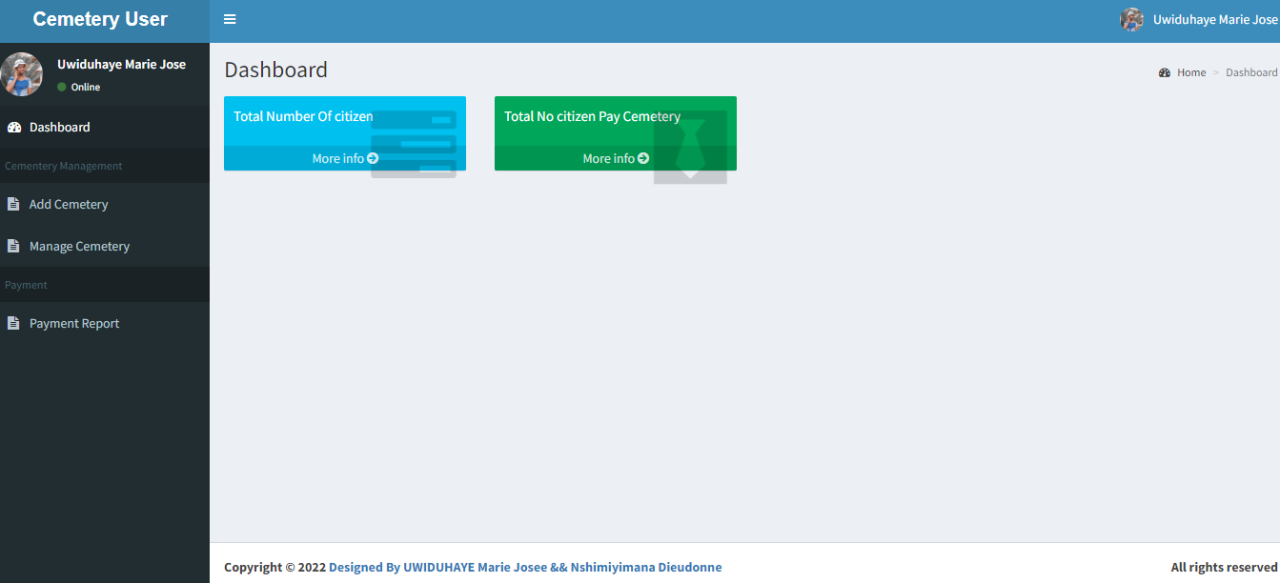

Figure 10:Cemetery user dashboard

## 5.2. Testing

### 5.2.1 Introduction

Software testing is an investigation conducted to provide stakeholders with information about the quality of the product or service under test Software testing also provides an objective, independent view of the software to allow the business to appreciate and understand the risks of software implementation.

Software testing can also be stated as the process of validating and verifying that a software program/application/product: Meets the business and technical requirements that guided its design and development, works as expected, and can be implemented with the same characteristics.

### 5.2.2 Testing technique

* **Grey Box Testing** is one of testing technique we used to test a software product with partial knowledge of internal structure of the application.
* **Black box testing is a powerful testing technique because it exercises a system end-to-end. Just like end-users “don’t care” how a system is coded or architected, and expect to receive an appropriate response to their requests, a tester can simulate user activity and see if the system delivers on its promises**

|  |  |  |
| --- | --- | --- |
| S/N | **Testing Activity** | **Testing Results** |
| 1 | Admin and cemetery user Login | Successfully |
| 2 | Addition of a cemetery user, admin | Successfully |
| 3 | Edit of cemetery user and admin | Successfully |
| 4 | Creating account, login, making application of people | Successfully |
| 5 | Payment | Successfully |
| 6 | View report of payment done by cemetery user | Successfully |
| 7 | Log out of all user | Successfully |

Table 7: Acceptance testing table

# CHAPTER 6: CONCLUSION AND RECOMMENDATIONS

## 6.0 Conclusion

We conclude that this system provides solution to bereaved where it helps them to pay grave via their telephone any time when connected to internet with help of MTN mobile money or Airtel money and there is no tome to lose or walking long distance. In addition, all data are said to have integrity this assures that the information stored is valid, accurate and consistency.

## 6.1 Recommendations

This application has successfully solved the problems of traditional payment methods. Regardless of the fact that the aims and objectives of the system are met, there is still room for further improvement.

With the recent technological advancements, we recommend IPRC Tumba students that in any future work features such as personalization and the development of the IOS version of this system should be taken into consideration to enhance the efficiency and effectiveness of the system.

# References

Abstractions for software architecture and tools to support them1995IEEE transactions on software engineering

information technology and business process redesign.1990The new industrial engineering

Methods of modeling and optimization of business processes.2019

Pros and cons of different sampling techniques2017International journal of applied research

UML 2 toolkit2003chicago John Wiley & Sons

A Java Version Controller for Distributed Computing Systems2017

Beginning PHP, Apache, MySQL Web Development2004John Wiley & Sons.

Burial terminology2005Rowman Altamira.a guide for researchers

Das2020Gas Leakage Detection and Prevention using IOT Scientific Research & Engineering Trends

Enabling scalable virtual organizations.2001The International Journal of High Performance Computing Applications

Last2017Deaths at the borders databaseJournal of ethnic and migration studies

Mathur2021An Android-based ApplicationJaipur Bus Finder

McLaughlin2012PHP & MySQL: The missing manualO'Reilly Media

Migueles, J. H., Cadenas-Sanchez, C., Ekelund, U., Delisle Nyström, Accelerometer data collection and processing criteria to assess physical activity and other outcomes2017Sports medicine

Reflective teaching in second language classrooms1994 Cambridge university press

Thayer2002Software system engineeringThayer, R. H. (2002). Software system engineering: A tutorial. Computer, 35(4), 68-73.

The archaeology of death and burial1999UK: Sutton.Phoenix Mill

The one-to-one interview2007International Journal of Therapy and Rehabilitation, 16(6), 309-314.

Topics in performance evaluation, measurement and characterization: Third TPC technology conference, TPCTC 2011, Seattle, WA, USA, August 29- September 3, 2011. Revised selected papers2012USASpringer

Tracing Your Family History on the Internet2014Pen and SwordA Guide for Family Historians

What Is MySQL? In The Definitive Guide to MySQL (pp. 3-19)2004. Apress, Berkeley, CA.